Title or Task: | Test for Photoshop APS108 Exam  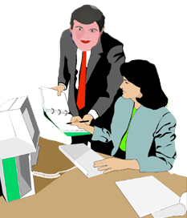
Description: | Correct images to create a new post production image
Files Required | APS108 post prod instructions.jpg  APS108 post prod one.jpg  APS108 post-prod-two.jpg
Suitable for Classes: | AIT • Multimedia • Cert II IT • Cert II Bus
Area: | Technology & Enterprise
Teacher: | Mr Peter Faulks
Timeline | 1 or 2 lessons
Date Due: | By end of week
Task Brief: | Working with various Photoshop techniques
Outcomes: | Technical ability - advanced

Items highlighted in yellow are tasks for you to complete
Items in Blue italics are help tips

APS108 Post Production Test (In class)

Type your name here:

Save this document as
surname postproduction.doc (surname = your surname)

You often will have work to create a finished product after all the work has been undertaken, In photography we use Photoshop and the industry standard so here is a short Exersize in Photoshop. Here we have two girls with background elements that we need to clean

We need to use Photoshop and the clone tool to remove the bins and the light pole and all the stuff in yellow. On the left of the pink girl we need to add her friend so that it looks like the three girls were together.
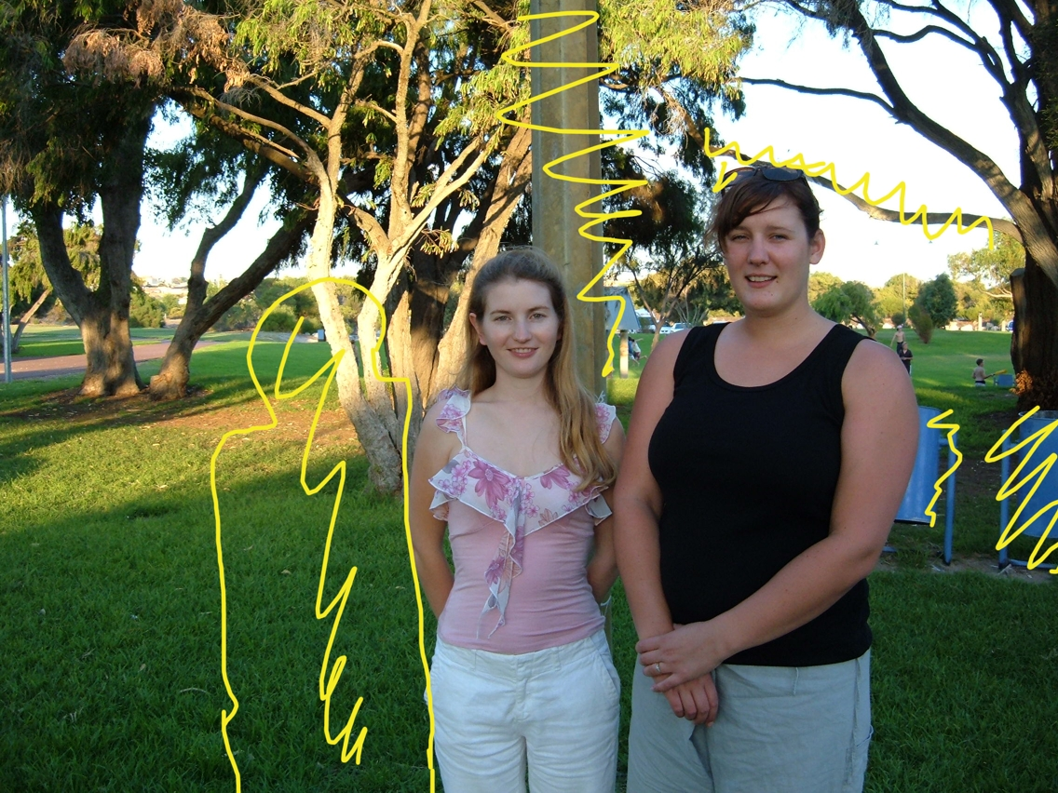
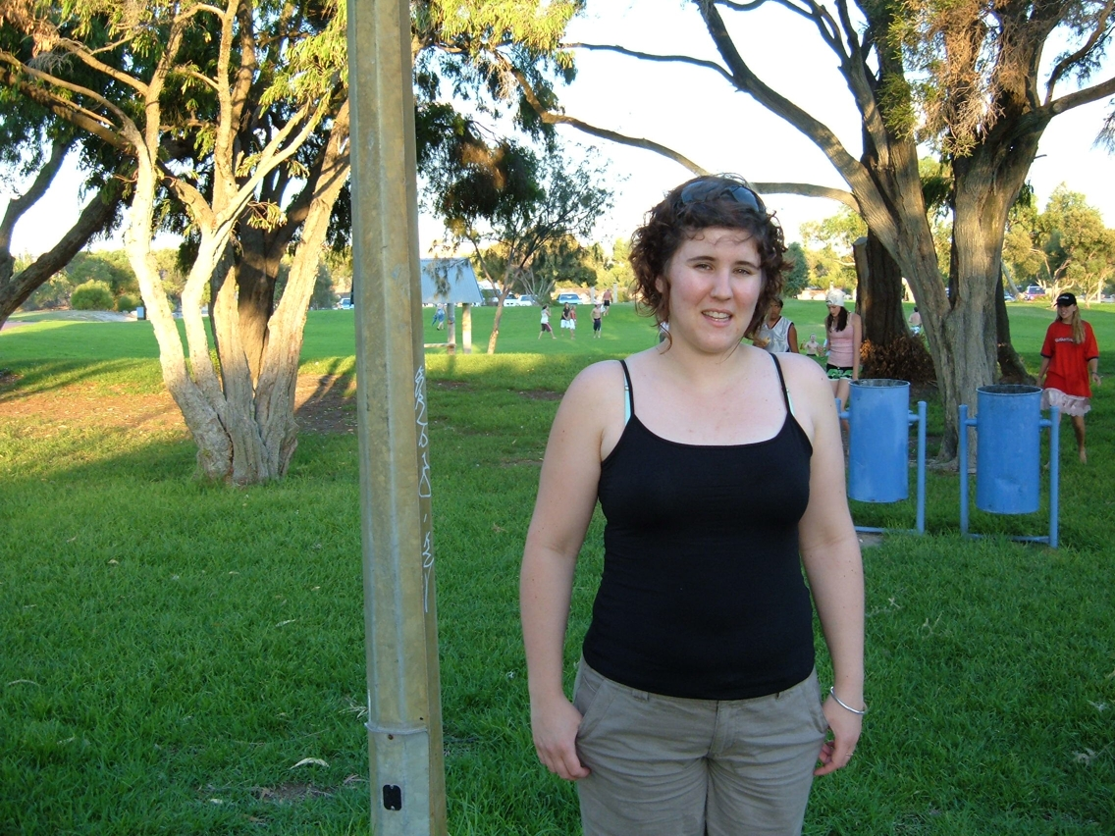Originals
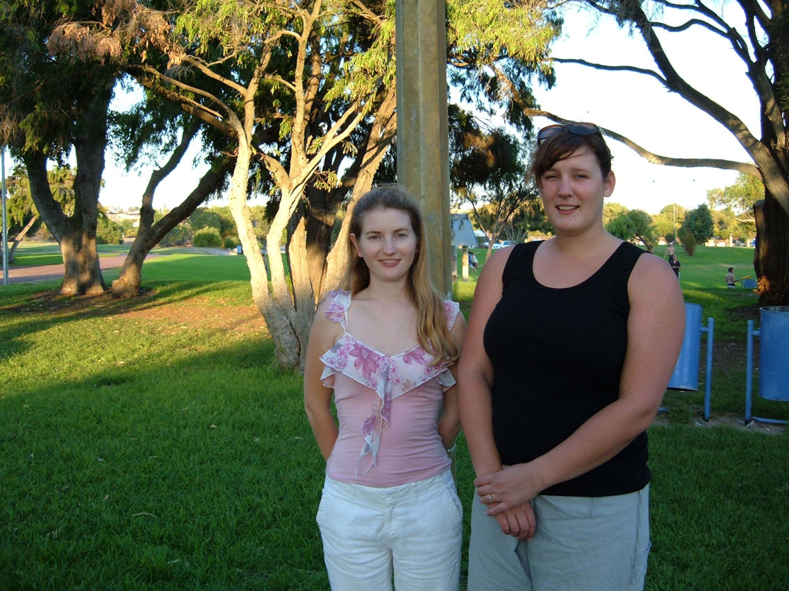
Using the visual instructions place one girl with a photo of two girls to create an image on three girls – elements drawn show where image must be manipulated after production

You can use the following files
APS108 post prod instructions.jpg
APS108 post prod one.jpg
APS108 post-prod-two.jpg

Make changes as shown(yellow squiggles) in the instructions for Two Girls

Use Photoshop Lasso Tool, Filters Extract and Clone Tool

Once you have saved a NEW copy of the work as Postproduction1.jpg

Open and Start work on the APS108 post prod one.jpg

Save this as surname Postproduction2.jpg (surname = your surname)

Paste screenshots here:

Final (Should look something like this)
But in full colour

Paste your screenshots here:

If you want an extra mark paste your girls onto a new background
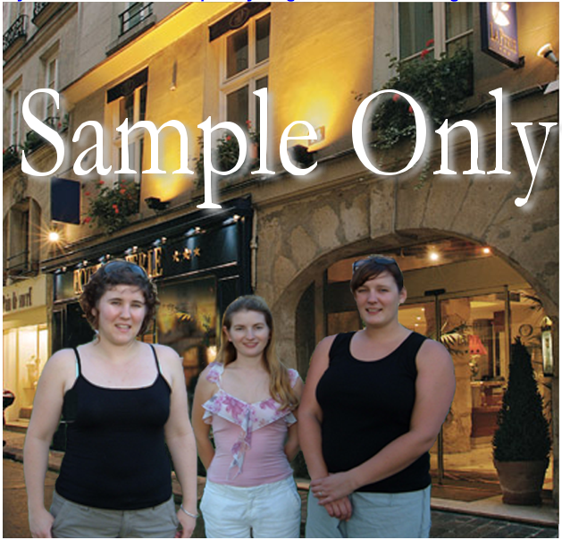

Marquee tools – various
Mask (results from marquee)
Crop (to marquee area)
Cut + paste (from another photo, and within same photo)
Copy + paste
Red-eye removal
Clone brush – hard edge
– soft edge
– detail (for
softening details, eg:wrinkles)
Eraser – soft edge
– hard edge
Fill tool
Flip - horizontal
Transparency - layer fill
Shape tools – fill disabled
Paint brush – pencil style
Paint
Save As yoursurname_GroupFinal.jpg

Tool |  | Explanation
Marquee |  | The Marquee is used to make selections. Choose from a rectangular, elliptical, single row or single column selection by clicking and holding. Then drag a selection within the image. Create a perfect circle or square by holding down the Shift key when dragging. Use the Crop tool to drag a crop area, adjust the resize markers and double click to crop an image
Lasso |  | The Lasso is a freehand selection tool. Hold down the mouse key and drag to draw a selection shape. Hold down the OPTION (Mac) or ALT (PC) key and single click to draw straight lines, or use the second tool in the toolbox.
Move |  | The move tool is used to move a selection or layer. Click and drag with the move tool to move selections. You can activate the move tool at any time by holding down the CTRL (PC) or Command (Mac) key.
Magic Wand |  | This tool selects areas according to similarity of colour or tonal range. Increasing the tolerance setting in the Options Palette decreases the similarity required to select colour. In other words, a higher number selects more of the image.
Airbrush |  | The airbrush paints with the foreground colour with a diffused spray. It is used to create soft edges and is particularly useful for adding shadows. You can increase the amount of paint that is released by increasing the pressure slider in the Options Palette. The size of the stroke is changed using the Brushes Palette.
Paintbrush |  | The paintbrush paints using the foreground colour. It takes its width from the Brushes Palette and can use wet edges. Holding down the Shift key constrains the paintbrush to horizontal, vertical or 45° lines.
Rubber stamp/Cloning |  | Sample an area for cloning by holding down the OPTION (Mac) or ALT (PC) key and clicking on the source image. Click and drag over the position where the image is to be cloned.
History Brush |  | The history brush tool lets you paint a copy of one state or snapshot of an image into the current image window. This tool makes a copy, or sample, of the image and then paints with it. The history brush tool works similarly to the rubber stamp tool, but on any state or snapshot of the image, not just the current one.
Eraser |  | The eraser replaces an area with the background colour. The size of the eraser can be set with the Brushes Palette. Holding down the OPTION (Mac) or ALT (PC) key allows that section of the image to revert to the previously saved version. This is called the Magic Eraser.
Line/Pencil |  | The line tool draws lines with the foreground colour while the pencil also uses the foreground colour and Brushes Palette when creating lines. Unlike the airbrush and paintbrush, it does not offer soft edges. The pencil can be used as an eraser by selecting the background colour. Horizontal and Vertical lines can be drawn by holding down the Shift key.
Blur/Sharpen/ Smudge |  | Blur softens hard edges on an image, while sharpen brings out more detail. Smudge allows you to create a water colour effect. It looks as if you have dragged your finger through wet paint.
Dodge/Burn/  Sponge |  | Dodge lightens specific areas, whilst Burn darkens them. The sponge allows for saturation (intensifying) of a colour or desaturation (decolouring). All tools are affected by the size of the brush chosen in the Brushes Palette.
Pen |  | The pen tool is used for creating and modifying paths.
Type |  | The type tool is used to add text in the foreground colour on a new layer. A range of formatting options is available. The second and fourth tools create a selection in the shape of the text. The third option creates vertical text. You can edit the text at any time using the type layer.
Measure |  | The measure tool calculates the distance between any two points in the work area. When you measure from one point to another, a non-printing line is drawn and the Info palette shows information about distance and angle.
Gradient |  | The gradient tool paints a blend of the foreground and background colours, or other preset gradients. Change settings with the Options Palette.
Paintbucket |  | The paintbucket fills areas of a similar colour with the foreground colour. It uses the same principle as the Magic Wand tool.
Eyedropper/color sampler | The eyedropper and color sampler tools are used to sample colour from images. You don’t need to use this tool to choose colours from either the colour picker or swatches.
Hand | The hand is used to scroll through a document to view areas that don’t fit within the Window. Click on the image and drag. To use the hand tool while another image is selected, hold down the spacebar.
Zoom | Zoom increases the magnification of the image. Either click or drag a selection box. To zoom out hold down the OPTION (Mac) or ALT (PC) key. Holding down the Command (Mac) or CTRL (PC) key and pressing either + or - will also zoom in or out.

Most tools use a standard mouse pointer to describe the area of their operation. You can change this to a crosshair by turning on the Caps Lock key. This is called the precise selector. You can also change the look of the screen by choosing from the screen display options at the bottom of the toolbox.

The first view is the normal screen view with the image contained inside a window. The second view shows a full screen view of the image with a toolbar. The third button shows the image in full screen mode, against a black background with no menu bar.

